
FITTRACK AI | PHASE 8 – PROJECT DEMONSTRATION
St. Anne's Arts and Science College
Department of Computer Science
Team Members | Register No | Project Name | Phase Topic
JAISREE.R | 222409465 | FitTrack AI -  Personalized Fitness Recommendations  Powered by AI | Phase 8  PROJECT  DEMONSTRATION
JANU SRI.D | 222409466
JECHINTHA JOYCE.S | 222409467
JENITA.G | 222409468

FitTrack AI
Personalized Fitness Recommendations Powered by AI
PHASE 8
PROJECT DEMONSTRATION
Project Name: AI FitTrack
Project Type: AI-powered Fitness Tracking Backend / RESTful API Application
Technology Stack: Node.js, Express.js, MongoDB, Mongoose, JWT, bcrypt.js, Google Gemini AI
Page 1

FITTRACK AI | PHASE 8 – PROJECT DEMONSTRATION
CONTENTS
8.1 Demonstration Overview
8.2 Project Setup Demonstration
8.3 Authentication Demonstration
8.4 Workout Management Demonstration
8.5 AI Recommendation Demonstration
8.6 Fitness Insights Demonstration
8.7 API Testing Demonstration
8.8 Demonstration Video
8.9 API Testing / Reference Link
8.10 Final Demonstration Evidence
8.11 Phase Summary
Page 2

FITTRACK AI | PHASE 8 – PROJECT DEMONSTRATION
8.1 Demonstration Overview
The final phase of FitTrack AI – Personalized Fitness Recommendations Powered by AI presents a
demonstration of the completed backend application. The purpose is to showcase the principal
features of the system and illustrate how the implemented RESTful APIs operate in a practical
environment.
The demonstration follows the application's main workflow, beginning with user authentication and
proceeding through workout management and AI-supported fitness services.
8.2 Project Setup Demonstration
The demonstration begins with the project environment and the backend server running. The
presenter may briefly show the project folder structure, server execution, database connection, and
required environment configuration before proceeding to API requests.
Sensitive configuration values, including secrets, credentials, and API keys, should not be exposed
in screenshots or the demonstration recording.
8.3 Authentication Demonstration
Authentication is demonstrated through the registration and login APIs. The sequence shows a user
registering an account and then signing in with the registered credentials. The authentication token
returned after login is used to access protected resources.
8.4 Workout Management Demonstration
Workout management is demonstrated using the available workout APIs. The presentation covers
the main operations supported by the backend:
•Adding a workout record.
•Viewing workout records for the authenticated user.
•Retrieving a particular workout by its identifier.
•Updating existing workout information.
•Deleting a workout record.
8.5 AI Recommendation Demonstration
The AI recommendation feature is demonstrated by submitting the required fitness information to
the AI service. Inputs such as age, fitness goal, and experience level are used by the service to
generate personalized fitness recommendations. The resulting output is presented through the API
response.
Figure 8.4: AI Workout Recommendation Demonstration
Page 3

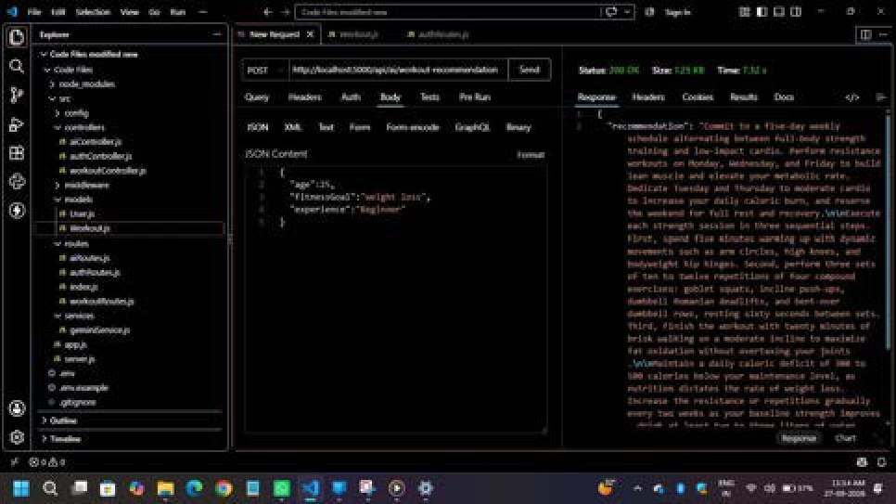
FITTRACK AI | PHASE 8 – PROJECT DEMONSTRATION

8.6 Fitness Insights Demonstration
The fitness insights feature is demonstrated using workout statistics, which may include total
workouts, average workout duration, and total calories burned. The returned response illustrates the
fitness-related insights generated by the AI service from the available workout information.
Figure 8.5: AI Fitness Insights Demonstration
Page 4

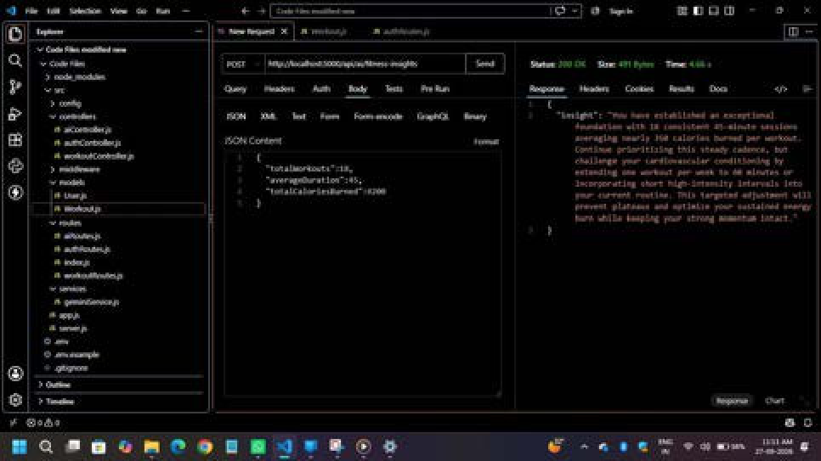
FITTRACK AI | PHASE 8 – PROJECT DEMONSTRATION

8.7 API Testing Demonstration
The implemented APIs are demonstrated using an API testing tool such as Postman or Thunder
Client. The presenter sends requests to the backend and displays the corresponding JSON responses.
The demonstration sequence covers the following API groups:
1.Authentication APIs
2.Workout APIs
3.AI APIs
Where appropriate, the demonstration should show the request method, endpoint, input data,
response status, and returned JSON body. The displayed results should be captured from the actual
running application.
8.8 Demonstration Video
A recording of the project demonstration may be provided as supporting evidence. The video should
show the running backend and the principal features presented during the project demonstration.
Demonstration Video
Demo vid

Page 5

FITTRACK AI | PHASE 8 – PROJECT DEMONSTRATION
8.9 API Testing / Reference Link
The API testing collection or other relevant project reference link may be included in this section to
support evaluation and verification.
API Testing / Reference Link
Api testing

8.10 Final Demonstration Evidence
The final demonstration provides practical evidence of the major components of AI FitTrack and
their accessibility through the implemented APIs. It brings together authentication, workout
management, database interaction, and AI-based recommendation and fitness-insight features
developed during the project.
The final evidence package may include the screenshots and links identified in this phase. All
placeholders should be replaced only with genuine screenshots, recordings, and working references
from the project.
Figure 8.6: Consolidated Final Demonstration Evidence
Demonstration vedio

8.11 Phase Summary
This phase presents the demonstration sequence for the AI FitTrack backend, from project setup and
authentication to workout operations and AI-powered fitness services. Screenshots, a demonstration
recording, and API reference links can be added to document the live demonstration and support
project evaluation.
Page 6

